MRBF Annual Bible Conference
2008

Bethel Baptist Church

Kalispell, MT

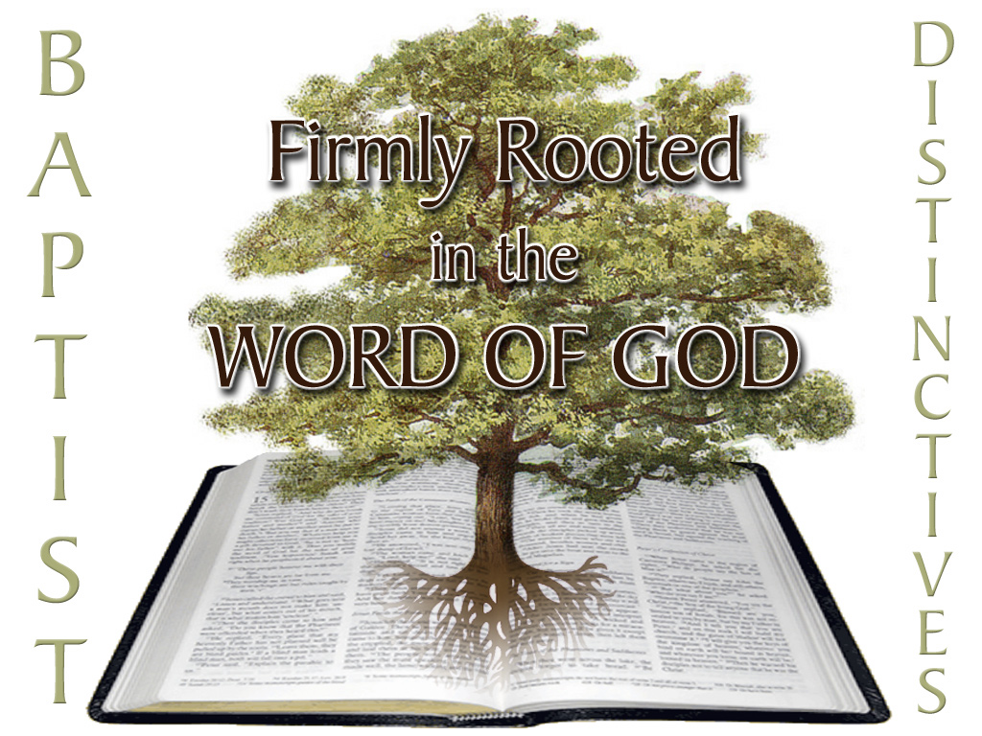
Why I am a Baptist

Baptists have a heritage, both historically and more importantly theologically.

The removal of a denominational marker from our church names is like McDonalds, Hardies, and Wendy’s all agreeing to rename their stores “Fast Food Outlets.” Branding is important in the business world; why should it not be for us who have much more to offer and much more at stake?

There are eight distinctives which have been agreed upon historically by Baptists to identify Baptists.

I am a Baptist because:

I believe the Bible is the only rule for faith and practice

2 Tim. 3:15-17; Acts 17:11; 2 Peter 3:1, 2; Rev. 22:18, 19; 1 Thes. 2:13; Gal. 1:8

Tradition, Reason, Experience are not a basis for faith or practice

I believe church members must be born again

Mt. 28:19-20; Acts 2:41, 47

Qualifications for church membership as given in Scripture: Regeneration and Immersion

I believe the local church is autonomous

Matt. 18:15-17; 1 Cor. 5:4-5, 13; Acts 5:29; 15:25-26

The local church is complete within itself and has no governing agency over it

Three elements

Self-governing—no oversight by any other body

Independent—no obligations produced by denominational, associational, or fellowship alignments

Democratic—members are the ultimate authority, in accord with the Word of God

I believe in the priesthood of every believer

1 Peter 2:9

The right of every believer to interpret Scripture privately and to have direct access to God

I believe that every person has liberty of conscience (soul liberty)

Romans 14; 2 Cor 5:11

Freedom to worship according to the dictates of one’s heart and allowing anyone of any faith the liberty to worship whom and how they please

I believe there are only two ordinances—immersion and the Lord’s Supper

Matt. 28:19-20; Acts 2:41; 8:36-38; 1 Cor. 11:23-29

These are ordinances, not sacraments

These have reference to the atonement

I believe in the practice of separation

I believe in the separation of church and state

Acts 5:29, Matt. 22:17-22

I believe in ethical separation

2 Cor. 6:17; 1 John 2:15-17; Eph. 5:11

I believe in ecclesiastical separation

Rom. 16:17, 18; 2 Thes. 3:6, 14

Each of these, independently, does not make me a Baptist. All of these, taken in union with each other, have historically set Baptists apart from other denominations. They are “brand markers,” core elements which define what we are and which identify us to others.

Why We should Teach our Distinctiveness (Our Duty to Make Baptists)

We owe it to ourselves.

If we believe our distinctives, we should teach them.

If our distinctives are important enough for separation, they should be important enough to teach.

We owe it to our fellow (non-Baptist) Christians.

We recognize that non-Baptists can be saved.

We refuse, however, to join ecclesiastical forces with those who reject our distinctives.

We owe it to the unsaved.

We want people to become Christians.

We want people to adopt a biblically consistent Christianity and become a part of a church that is biblically consistent.

We owe it to Jesus Christ.

We desire complete obedience to His Word.

We refuse to pick and choose commandments to obey.

How We can Teach our Distinctiveness

Thorough Instruction of our own People

We need to teach our people what it means to be a Baptist.

We need to help them understand the truth and strength of our position.

Practical Confirmation of our Words by our Actions

Our Sunday Schools, Christian Schools, youth groups, and children’s programs should have a focus on teaching biblical truth.

These teaching elements of our churches should have as their goal the producing of obedient believers who understand their Baptist heritage.

Wise Treatment of Controversies

We should be able to produce a solid defense of the truth.

We should also be able to deliver a truthful condemnation of error.

Cultivated Unity among Ourselves

We tend to focus on Separation – from whom should I separate?

Perhaps we should place our focus on Fellowship – with whom can I fellowship?

There was a voluntary fellowship between the churches of the New Testament period.

A doctrinal or scriptural unity (Col. 4:16)

A separation unity (2 John 9-11)

A common practice unity (1 Cor. 11:16; 14:34; 16:1)

A fraternal unity (Rom. 16:16; 1 Cor. 16:19)

A spiritual service unity (2 Cor. 11:9; Phil. 4:15, 16)

A counsel unity (Acts 15)

A member exchange unity (Acts 18:24-28)

Larry R. Oats
Maranatha Baptist Bible College
Watertown, WI 53094
920-206-2324
Oats@mbbc.edu
Our Distinctives as Baptists

The distinctives discussed in this study are not the traditions of men which have become distinctive of Baptists. They are, rather, biblical truths that distinguished the local churches in the New Testament era and are distinctive of all true New Testament local churches, regardless of the name they use. Baptists have historically espoused all these distinctives, thus they have become known as the Baptist Distinctives. Some other denominational groups accept various of these biblical truths, but not all of them.

The Baptist Distinctives need to be emphasized to every generation of Christians. This is especially true as many Baptists and Baptist organizations have moved away from their biblical foundations, convictions, and distinctives in recent years. Modernism and new-evangelicalism masquerade under the name “Baptist,” as they do under many other names today.

If these truths are not biblically grounded, they should be rejected. If they are taught in Scripture, then they should be believed, defended, and obeyed.

Dr. Richard Weeks, Maranatha’s first academic dean, was an avid bibliophile and Baptist historian. Well educated, he pastored for several years in Chicago before going to Pillsbury and then Maranatha to teach Baptist Polity and Baptist History, among other classes. Not content with the usual BAPTIST acrostic for the Baptist distinctives, he began a study of the various lists of distinctives identified by a wide variety of Baptist writers—old and new, northern and southern, American and European, and especially Fundamental Baptists of the early 20th century. From this study he created a list of what he thought the key Baptist distinctives were, without trying to force them into an acrostic grid. He also established an order to these distinctives, considering not so much that some distinctives are more important than others, but rather that some distinctives tend to flow out of other distinctives. The result was BRAPSIS².
Session One – The Prime Distinctive

The Bible (and for church matters, the New Testament) is the only rule for faith and practice

Important Scriptures

The Bible is God’s revelation to man.

The Bible is our only authority for faith and practice.

Key Scriptures

2 Tim. 3:15-17

2 Peter 3:1, 2

1 Thes. 2:13

Acts 17:11

Rev. 22:18, 19 (cf. John 14:26; 16:13)

Gal. 1:8

Four historic sources for truth:

Scripture

Tradition

Reason

Experience

Bible claims its own exclusiveness (no other divine revelation).
Session Two – The Corporate Distinctives

Regenerate Church Membership

Concept of “Membership”

Only saved people were added to the local churches of the New Testament (Acts 2:41, 47)

Membership is intimated in Acts 4:23; 6:3, 5; 13:1

Unbelievers are regarded as intruders in the local church (Jude 4).

Thyatira was rebuked for tolerating unbelievers in its membership (Rev. 2:20).

The nature of the church demands a regenerate membership.

Qualifications for church membership as given in Scripture: regeneration and immersion

Mt. 28:19-20 places the order as regeneration, baptism, and church membership

Acts 2:41, 47 puts this order into practice in the early church

Autonomy of the Local Church

The local church is complete within itself and independent of any external ecclesiastical controls – Mt. 18:15-17; 1 Cor. 5:4-5, 13; Acts 5:29; 15:25-26.

Three elements

Self-governing—no oversight by any other body.

Independent—no obligations produced by denominational alignment.

Democratic—members are the ultimate authority, in accord with the Word of God.

The New Testament model for local church government is congregational rule.

The congregation disciplines its own membership.

The congregation elects its own officers.

The congregation commissioned Barnabas and Saul as missionaries (Acts 13:1-3).

The church at Antioch, not the leaders, sent men to Jerusalem to resolve a doctrinal dispute (Acts 15:1-3).

Churches are responsible to maintain their own doctrinal integrity (Rom. 16:17, 18; Titus 3:10).

Churches are responsible to celebrate the ordinances (Acts 2:41, 42; 1 Cor 11:23-26).

Churches are to establish their own system of worship and service opportunities (1 Cor 14:40).

Churches are responsible for settling their own internal affairs (1 Cor 6:1-5).

The churches chose the messengers who took the offering to Jerusalem (1 Cor. 16:3; 2 Cor. 8:19, 23).

There are two offices in the New Testament church.

Pastor – spiritual leader

Deacon – temporal leaders

Office of the Pastor

There are five words in the New Testament that speak of the pastor’s ministry.

“Pastor”

“Bishop”

“Elder”

“Preacher”

“Teacher”

Scripture teaches that these three words describe different aspects of the same office.

Paul used all three words as synonyms when he preached to the elders from Ephesus at Miletus (Acts 20:17-28).

Paul used the words “elder” and “bishop” interchangeably (Titus 1:5-7).

Peter uses all three words to describe the same office (1 Peter 5:1, 2).

Office of the Deacon

Diakonos

The origin of the office

We understand Acts 6:1-7 to record the election of the first deacons.

They were elected to meet the need for physical, material service in the local church (6:1, 2).

The function of the office

From the beginning, the apostles gave deacons charge of a temporal, practical ministry.

Some deacons exercised a spiritual ministry also.

The main contrast between requirements for pastors and deacons is that deacons are not required to be “apt to teach” (1 Tim. 3:8-13).

Session Three – Member Distinctives

Priesthood of the Believer

The Bible teaches that Christ is our High Priest. This is the foundation for the priesthood of the believer.

Three aspects to the Priesthood of the Believer.

The individual believer enjoys access to God (Heb. 4:16; 10:19, 20; Eph. 2:18).

The corporate body of believers – the church – serves God.

Evangelization of the lost – we are their priests and prophets.

Emphasis is Godward.

Limited to born-again believers

Only believers are called priests

Unbelievers cannot stand before God except to repent or to be judged

Soul Liberty

Soul Liberty is the freedom to hold beliefs, to worship, and to profess one’s beliefs according to the dictates of one’s heart and allowing anyone of any faith the liberty to worship whom and how they please.

Scripture: Romans 14:5, 12; 2 Cor 5:11

Emphasis is manward.

Pertains to all humans, not just believers

Soul Liberty is worked out in three arenas:

Political – Religious Liberty

Personal – Freedom of Conscience

Ecclesiastical – Christian Liberty

Results of Soul Liberty

Leads away from churches in which the people have no voice.

Leads away from Christians who do as they please and instead becomes a basis for Biblical standards.

Develops an incentive to genuinely “win” the lost to Christ, not coerce them or trick them into a “conversion.”
Session Four – Disentangling Distinctives

Immersion and Lord’s Supper, the only two ordinances

Introduction

The Bible teaches that these ordinances are each:

A memorial

A symbol

A prophecy

Authority

From Christ

The Great Commission - Matt. 28:19-20

The Last Supper - Luke 22:19-20

New Testament Teaching

Baptism - Acts 8:38; 9:18; 10:48; Rom. 6:1-6

The Lord’s Supper - Acts 20:7; 1 Cor. 11:23-24

Baptism

Its only mode is immersion.

Significance

Baptism is a “figure” of salvation, literally a type. It does not put away sin, but is the answer of a good conscience, or an act of obedience to God (1 Pet. 3:21; Rom. 6:17).

It is a memorial of Christ’s death (Rom. 6:3).

It is a symbol of the believer’s relationship to Christ (Rom. 6:4).

It is a prophecy of the believer’s resurrection with Christ (Rom. 6:5).

It is a picture of the death, burial and resurrection of Christ.

It is the introductory rite of admission into the local church.

The proper authority for baptism is the local church (Acts 2:41).

The proper administrator of baptism is whoever is designated by the local church to perform the ordinance.

The proper recipient of baptism is a regenerate individual who desires membership in the local church (Acts 2:41, 47)

Lord’s Supper

It is commanded by Christ (Matt. 26:26-29; Mk. 14:22-25; Lk. 22:14-20; 1 Cor. 11:23-34).

It is to be observed in the local churches (Acts 2:42; 20:7; 1 Cor. 11:20, 33, 34).

Its significance is explained in the New Testament.

It pictures the communion of the saints with Christ and with each other (1 Cor. 10:16-21).

It is a memorial of Christ’s death (1 Cor. 11:24, 25).

Its elements are symbols of Christ’s body and shed blood (1 Cor. 10:16; 11:24, 25).

It is a prophecy of His return for us and of our eating with Him in Heaven (Matt. 26:29; Mk.14:25; Lk. 22:16; 1 Cor. 11:26).

The New Testament spells out clear terms for participation at the Lord’s Table.

Regeneration – only saved people are to participate in the Lord’s Supper.

Baptism – the order was established by the early church. Godliness – Paul commanded believers whose lives were sinful to abstain from the Lord’s Table (1 Cor. 5:9-12) .

Three theological positions

Transubstantiation - Roman Catholic

Consubstantiation - Lutheran

Memorial - 1 Cor. 11:23-24

Three types of administration

Open

Close

Closed

S₂: Separation

Separation of Church and State

Four possible relationships between Church and State:

The Church above the State, as in Romanist countries.

The Church alongside the State, as in the countries of Europe which have State churches.

The Church under the State, as in totalitarian countries.

The Church separate from the State, as in the United States.

We do not believe in the last relationship just because we enjoy it in America or not only because it is the most advantageous to religious liberty, but because it is taught in the Bible!

Matthew 22:17-22.

There is a realm called “Caesar’s,” that is the realm of civil government.

There is a realm called “God’s,” that is the realm of spiritual truth, represented on earth today by local churches.

Acts 5:29

What separation of church and state is not:

Separation of God and state

Separation of church from state

Not a constitutional term

What is the church’s relationship to the state?

Isolate—Christ did this

Participate—Acts 16:35ff

Separation ethically and ecclesiastically

Biblical Basis for Separation

Separation from unsaved individuals

2 Corinthians 6:14-7:2

Immorality

1 Corinthians 5:1-5

Doctrine

Romans 16:17-18

1 Timothy 6:3-5

2 John 9-11

Life Style

2 Thessalonians 3:6-15

Refers to a believer who is purposefully walking disorderly

Theological Basis

God is holy

I am to be holy – 1 Peter 1:15

The church is to work toward perfection – Eph 5:27

Scripture warns of doctrinal decay

1 Tim 4:1-2

2 Tim 4:3-4

2 Cor 11:13-15

The local church and pastor have a responsibility to maintain sound doctrine

Acts 20:28-32

1 Tim 3:15; 4:6, 16; 6:20

2 Tim 1:13-14; 4:15

2 Pet 3:17

Application

Levels of Association

Personal

Recreational

Commercial

Professional

Educational

Ecclesiastical

Variables in Association

Is it a matter of orthodox doctrine?

Christianity

Is it a matter of doctrinal distinctiveness?

Baptist

Is it a matter of philosophical direction?

Fundamentalism

Is it a matter of significance to our church?

Larry R. Oats
Maranatha Baptist Bible College
Watertown, WI 53094
920-206-2324
Oats@mbbc.edu

An Excursus on Elder Issues in the 21st Century

The use of the term elder in Baptist churches has a full and rich history. For much of Baptist history, pastors were called elders. It is the more common New Testament term, and in a time when the wisdom of age was held in high regard, elder was a term of great respect.

John MacArthur - Elder Rule

John MacArthur has popularized the concept of “elder rule.”

This model is akin to the Presbyterian form in that it commonly designates the clergy as “elders.”

The model differs from the classic Presbyterian form in several respects.

The local church makes a decision to adopt elder rule.

The elders then become the leaders of the church, making all decisions in place of the congregation.

The congregation does not even elect its elders as in the Presbyterian model.

Instead, the elders elect new elders. The elders become a self-perpetuating group who lead the church.

Bishops and pastors are terms for the elders.

MacArthur prefers the term elder because it is free from the nuances imposed upon bishop and pastor by the culture.

The three terms define a variety of functions or characteristics.

Duties of the Elders

Overseeing the affairs of the local church.

Elders are not subject to any higher earthly authority; their authority over the church is by precept and example (Heb 13:7).

Elders are not to operate by majority vote; there should be unanimity in decisions (1 Cor 1:10; Eph 4:3; Phil 1:27; 2:2).

Preach and Teach (1 Tim 5:17; Titus 1:7, 9)

Partners in prayer (James 5:14)

Shepherd the flock (Acts 20:28)

Includes determining church policy (Acts 15:22)

It does not include business details, public relations, minor financial matters, and other day-to-day operations of the church (Acts 6:3-4).

Selection of Elders

Cheirotoneo should not be used to imply that a congregational vote by show of hands was taken (although it was used that way for votes taken in the Athenian legislature).

In Acts 14:23 it was Barnabas and Paul who did the choosing.

2 Cor 8:19 uses the term to describe the appointment of a brother “by the churches,” which means he was not selected by a single congregational vote, but rather by the consensus of the leaders.

So “using the term cheirotoneo in an exaggerated, literal way is not sufficient to support the idea of the election of elders by congregational vote.”

Three-step process in the early transition period of the church:

First, apostles selected and ordained elders (Acts 14:23).

Second, those who were close to the apostles appointed elders (Titus 1:5).

Finally, elders appointed elders (1 Tim 4:14). This is the current practice – church leadership appointing elders.

Payment of Elders

Elders were paid in the early church (1 Tim 5:17-18).

The nature of ministry demands support (1 Cor 9:1, 3-9)

“Such subsidy is optional” (1 Cor 9:6).

“Elders may choose to support themselves by working outside the church.”

Number of Elders

“The norm in the New Testament church was a plurality of elders. There is no reference in all the New Testament to a one-pastor congregation.”

A plurality of elders “is the only pattern for church leadership given in the New Testament.” “Only by following this biblical pattern will the church maximize its fruitfulness to the glory of God.”

MacArthur rejects the argument that the “angels” in Rev 2 and 3 refer to pastors.

Leadership among Elders

Leadership does not imply superiority.

James was “apparently regarded as a leader and spokesman for the entire church” (Acts 12:17; 15:13), but “was not in any kind of official position over the other elders.”

The Elders and the Congregation

The Congregation is to respect, love, appreciate and cooperation with the Elders (1 Thes 5:12-13).

They are also to obey them (Heb 13:7).

Mark Dever – Lay Elders

Number of Elders

He agrees with MacArthur that churches should have a plurality of elders.

He has reported the historicity of Baptists using plural elders in their churches in the 18th and 19th centuries.

The letters to the seven churches are addressed to the singular messenger of each church.

Paul wrote not to the elders in Ephesus, but to Timothy alone.

It is consistent with choosing one elder and giving him the primary teaching responsibility.

Elders and Church Staff

Church “staff” consists of people the church has paid to work for the church (which includes individuals who are not elders).

The majority of the church elders are not paid.

Elders and the Pastor

Elder, bishop and pastor are used interchangeably.

Some elders came from outside the local church (such as Titus), while others were appointed from within the local congregations.

Some were supported fulltime by the flock (1 Tim 5:17-18; Phil 4:15-18), but others worked at another job (such as Paul).

Elders and the Congregation

Five characteristics of this relationship – recognition, trust, godliness, carefulness, and results.

The responsibility for the discipline and doctrine of the congregation lies with the congregation as a whole. Here Dever differs from MacArthur.

“Congregationalism may or may not be attractive, efficient, well understood, well practiced, easy, universally loved, impervious to distortion or corruption, but it is biblical.” Only the congregation and the whole congregation is responsible to God for the conduct and belief of the church (Matt 18:15-17; 1 Cor 5; 2 Cor 2:6-8; 2 Tim 4:3).

The elders do not “rule” in the typical sense, but direct or lead.

Elders as “Super-Deacons”

There is no specific individual who has popularized this position (that the professor is aware of).

This position appears to be an attempt to establish the role of elder, but maintain the office of pastor.

This position is similar to the convention church system of pastor(s), deacons, and trustees, but using different terminology.

Any position that separates the office of elder from the office of pastor is unbiblical.

Primary sources are John MacArthur, “Answering Key Questions about Elders, “ http://www.gtv.org/Resources/Positions/2164 and John MacArthur, “Biblical Eldership,” http://www.gbcmj.com/elders.htm.
Primary sources are Mark Dever, “Elders” in A Display of God’s Glory: Basics of Church Structure (Washington, D.C.: 9Marks, 2001), 17-28.

